**Class Diagrams**

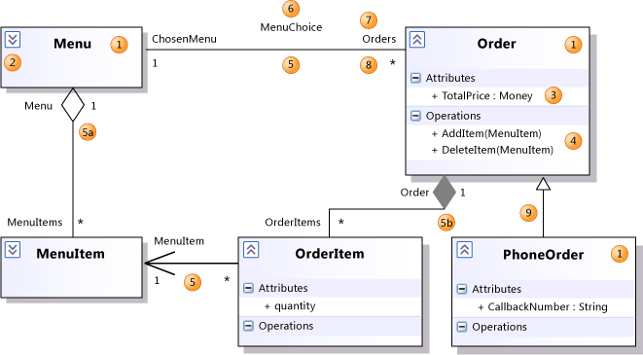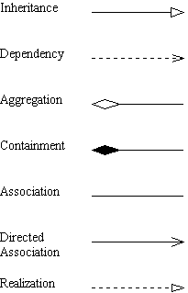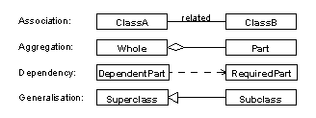

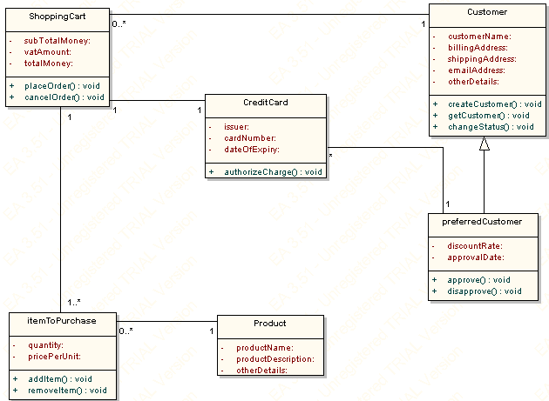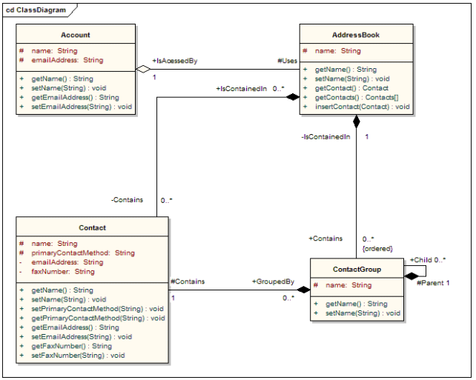

<https://i-msdn.sec.s-msft.com/dynimg/IC315445.jpeg>

<http://www.databaseanswers.org/data_models/uml_class_diagram_for_shopping_cart/images/uml_class_diagram_cart.gif>

<http://thietkeweb.luatsutunhan.com/wp-content/uploads/2015/06/huong-dan-cach-thiet-ke-class-diagram.png>

**Use Case Diagrams**

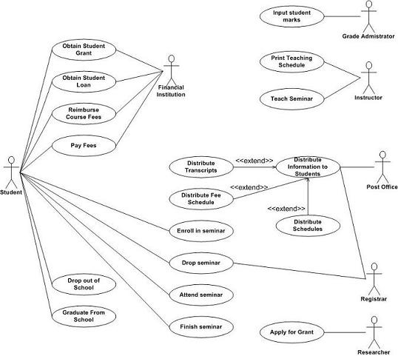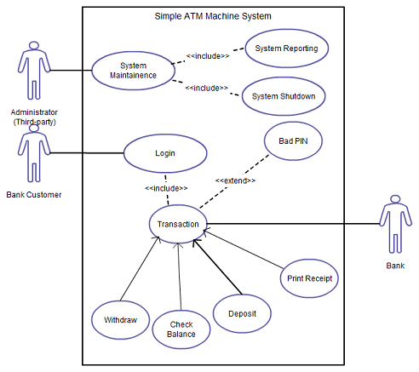

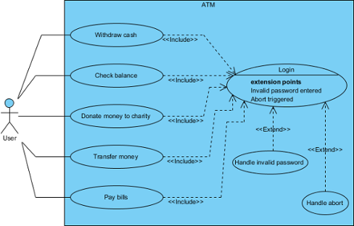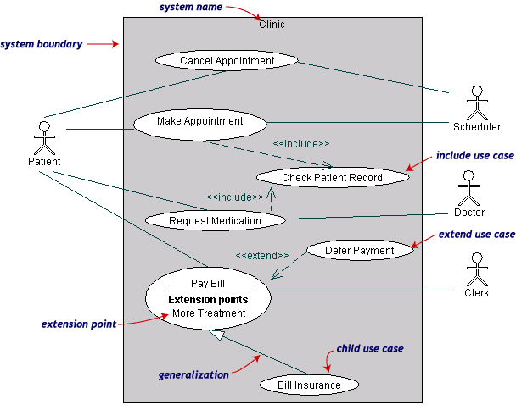

<http://www-rohan.sdsu.edu/~haytham/post/uml_2_files/image002.gif>

<http://creately.com/blog/wp-content/uploads/2012/01/Use-Case-Diagram.png>

<https://images.visual-paradigm.com/docs/vp_user_guide/11/94/2575/2745/sample_use_case_diagram_19967.png>

<http://agilemodeling.com/images/models/useCaseDiagram.jpg>

Elevator

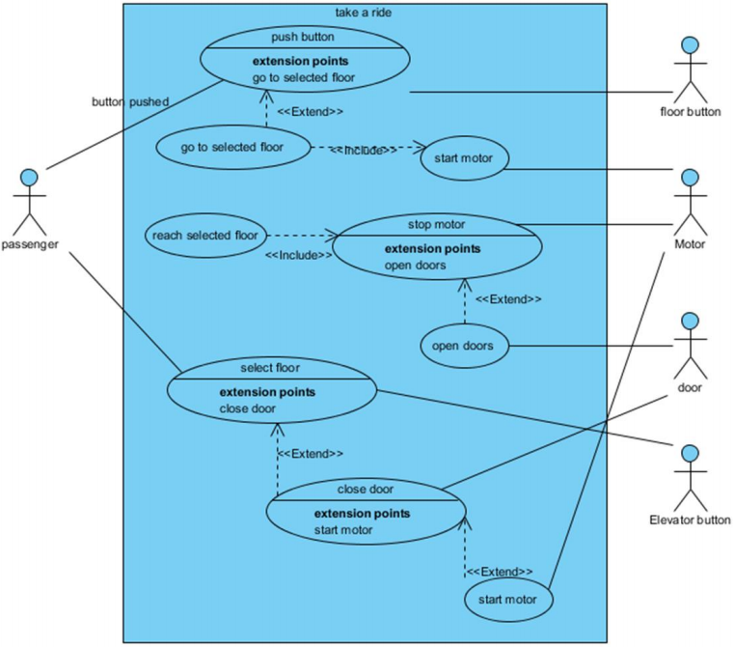

**Activity Diagram**

<http://www.conceptdraw.com/samples/resource/images/solutions//BUSINESS-PROCESS-DIAGRAMS-UML-Activity-Diagram.png>

<http://www.teach-ict.com/as_as_computing/ocr/H447/F453/3_3_6/uml/miniweb/images/activity-diagram.gif>

<http://4.bp.blogspot.com/-UlVKE6xeo5E/T4fRDoxDxNI/AAAAAAAAAQ0/PQ2omom9qUM/s1600/Activity+Diagram+Hospital+Mgmt+Test.JPG>

Facebook login <https://creately.com/jupiter/diagram/image/gto0x9981>

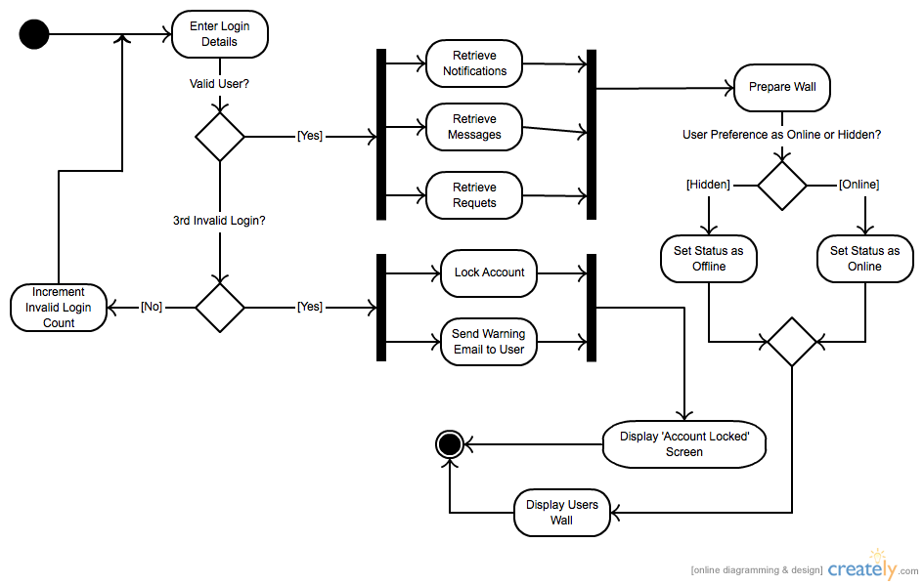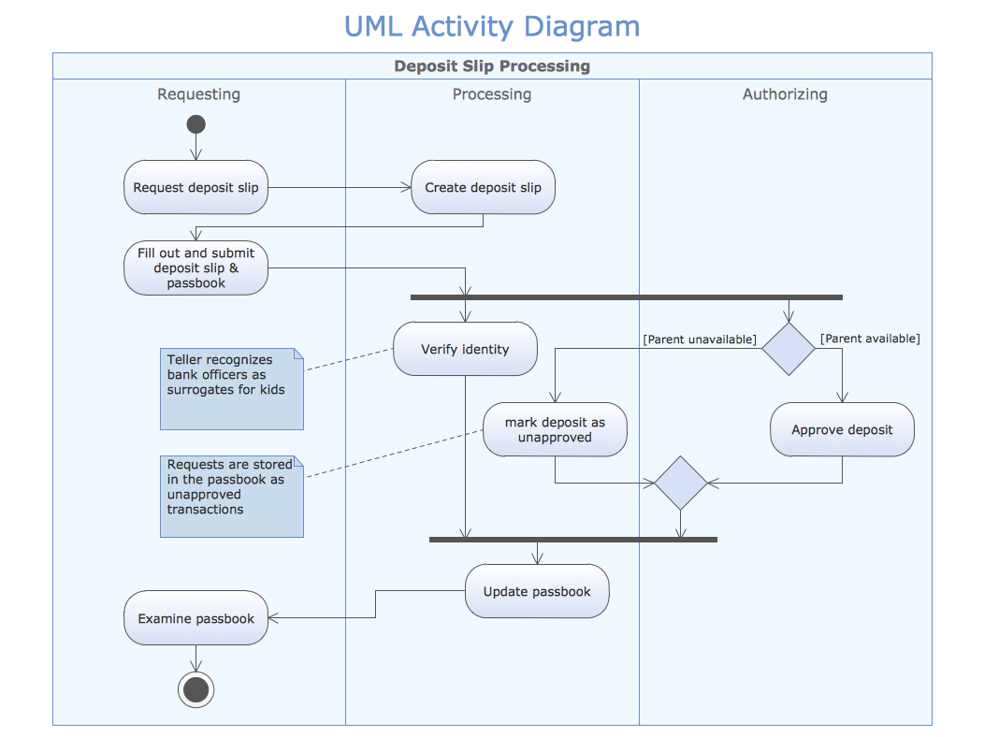

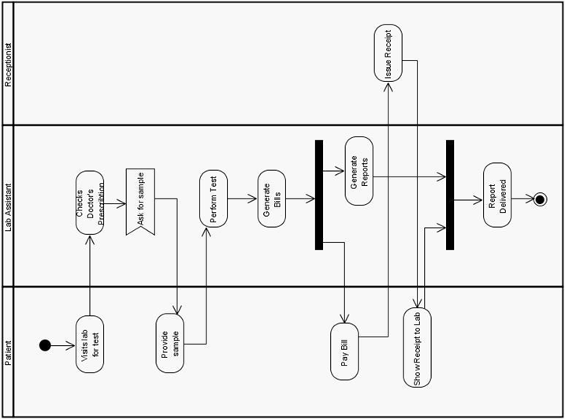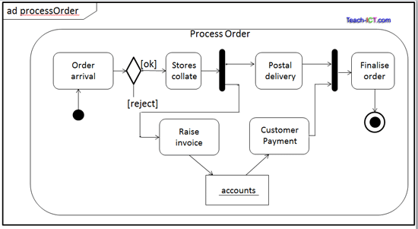

<http://www.uml-diagrams.org/examples/activity-example-google-sso.png>

<http://www.uml-diagrams.org/examples/activity-example-document-management.png>

<http://www.tutorialspoint.com/uml/images/uml_activity_diagram.jpg>

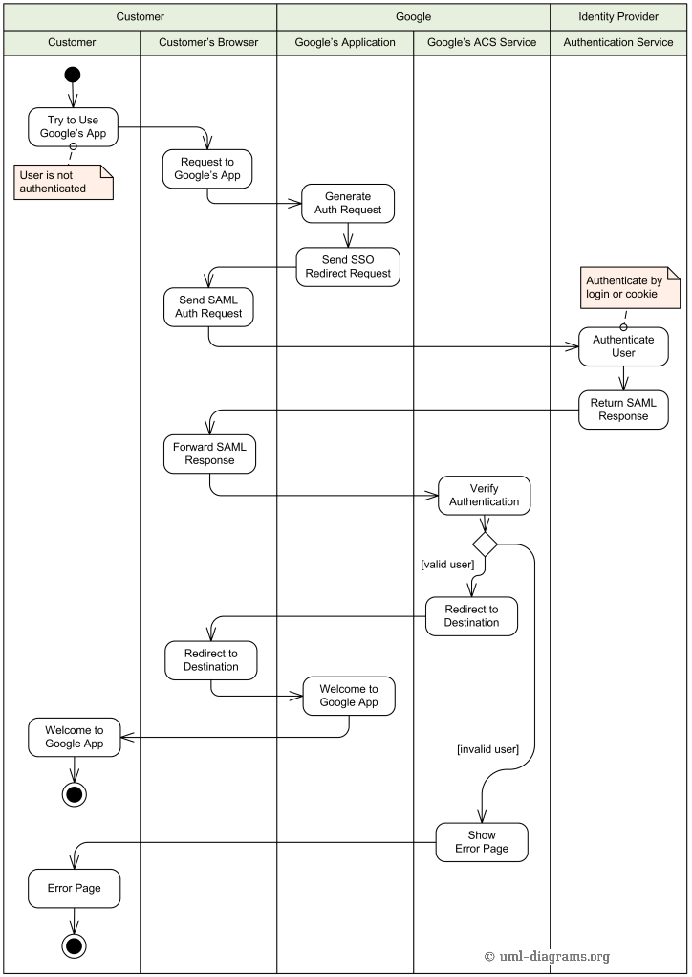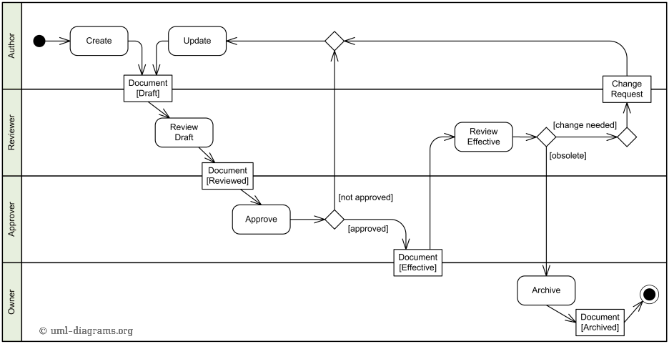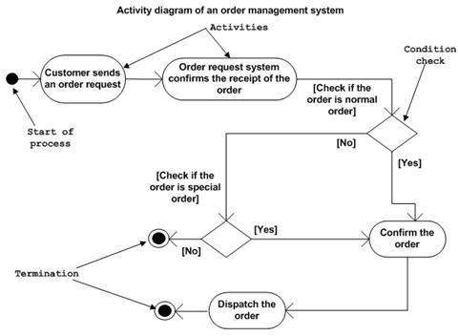

State Machine Diagram

CD Writer

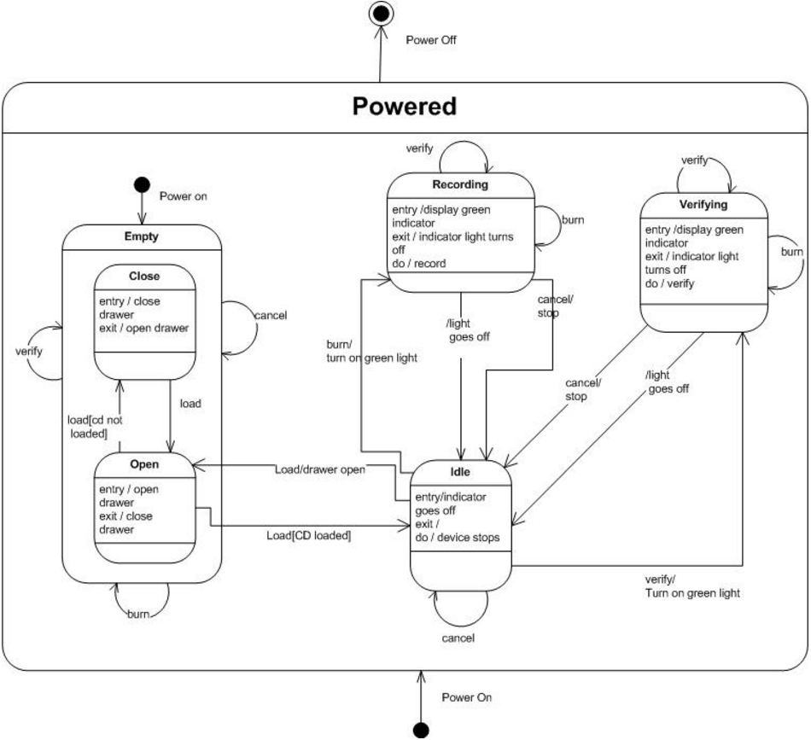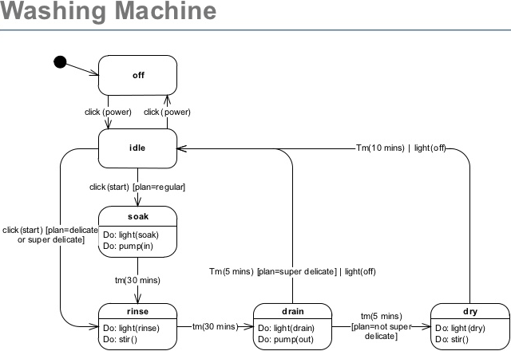

<http://image.slidesharecdn.com/asissession06statechart-090707111113-phpapp02/95/uml-statechart-diagrams-22-728.jpg?cb=1246965119>

<http://stackoverflow.com/questions/23376993/state-machine-for-a-cd-writer>

<http://users.dickinson.edu/~wahlst/491/lectures/lec13/sysmod/state.gif>

<http://www.c-jump.com/CIS77/images/UML_phone_call_State_diagram.png>

<http://www.sparxsystems.eu/fileadmin/user_upload/Screenshots/Buch_figures/en/Images/Fig_29_Example_State_Machine_Diagram_Automatic_Teller_Start-up.png>

<http://www.uml-diagrams.org/examples/state-machine-example-bank-atm.png>

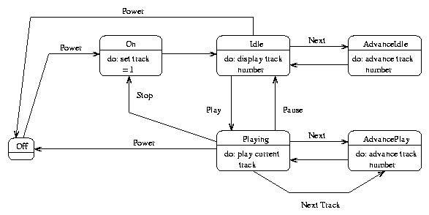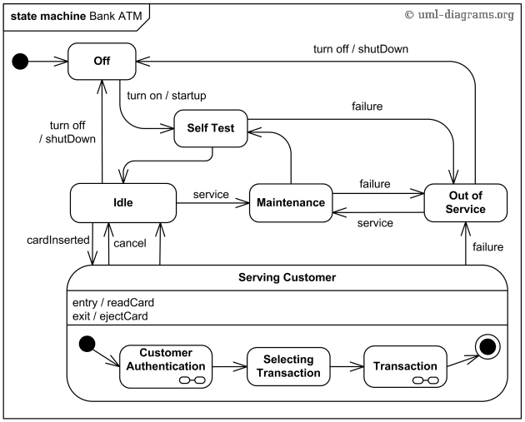

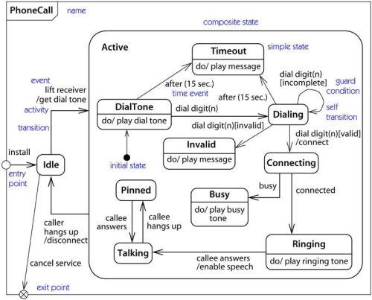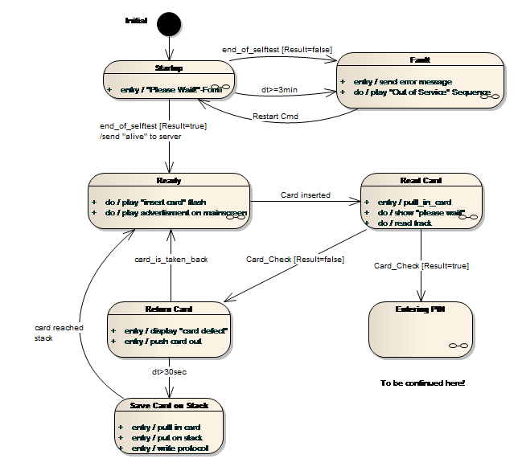

Sequence Diagram

<http://www.tracemodeler.com/articles/a_quick_introduction_to_uml_sequence_diagrams/images/a%20typical%20sequence%20diagram.png>

<http://www.uml-diagrams.org/examples/sequence-example-facebook-authentication.png>

<http://banking-system.wikispaces.com/file/view/seq1.jpg/243616677/seq1.jpg>

<https://blogs.msdn.microsoft.com/habibh/2009/07/29/use-uml-sequence-diagrams-in-team-system-2010-to-reverse-engineer-your-code/>

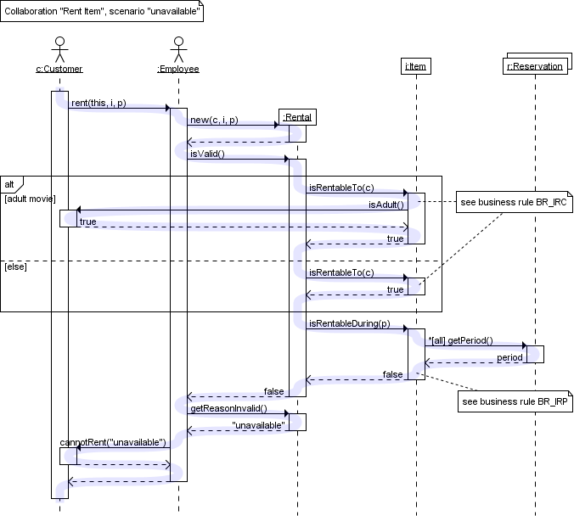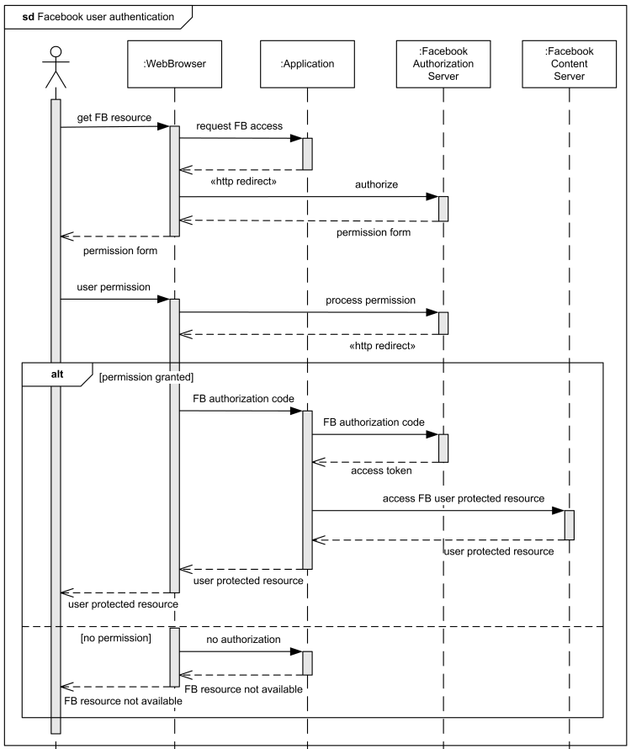

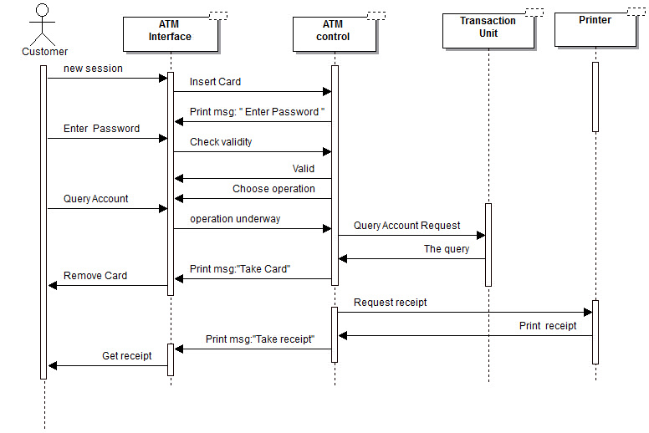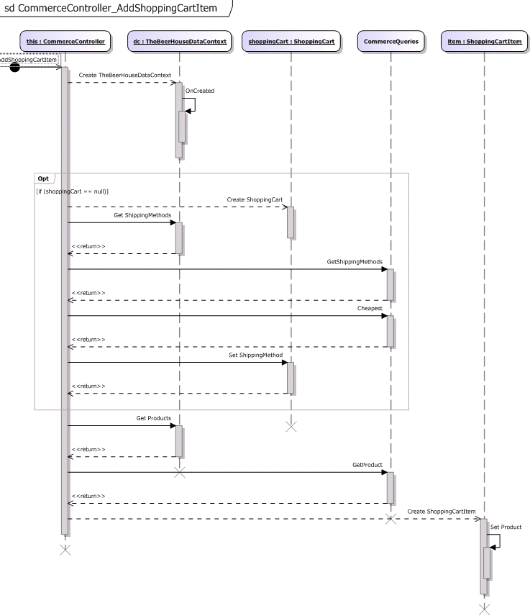

Communication Diagram

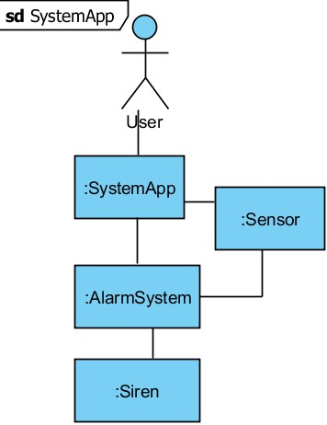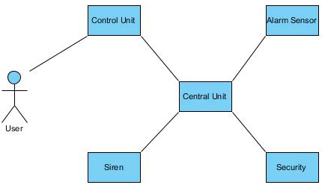

**Kano Model**

